**WEEK 2**

**PL/SQL**

**MANDATORY**

1) CONTROL STRUCTURES

i) Loan Interest rates

BEGIN

FOR cust IN (

SELECT c.CustomerID, l.LoanID, l.InterestRate, c.DOB

FROM Customers c

JOIN Loans l ON c.CustomerID = l.CustomerID

)

LOOP

IF MONTHS_BETWEEN(SYSDATE, cust.DOB)/12 > 60 THEN

UPDATE Loans

SET InterestRate = InterestRate - 1

WHERE LoanID = cust.LoanID;

END IF;

END LOOP;

COMMIT;

END;

/

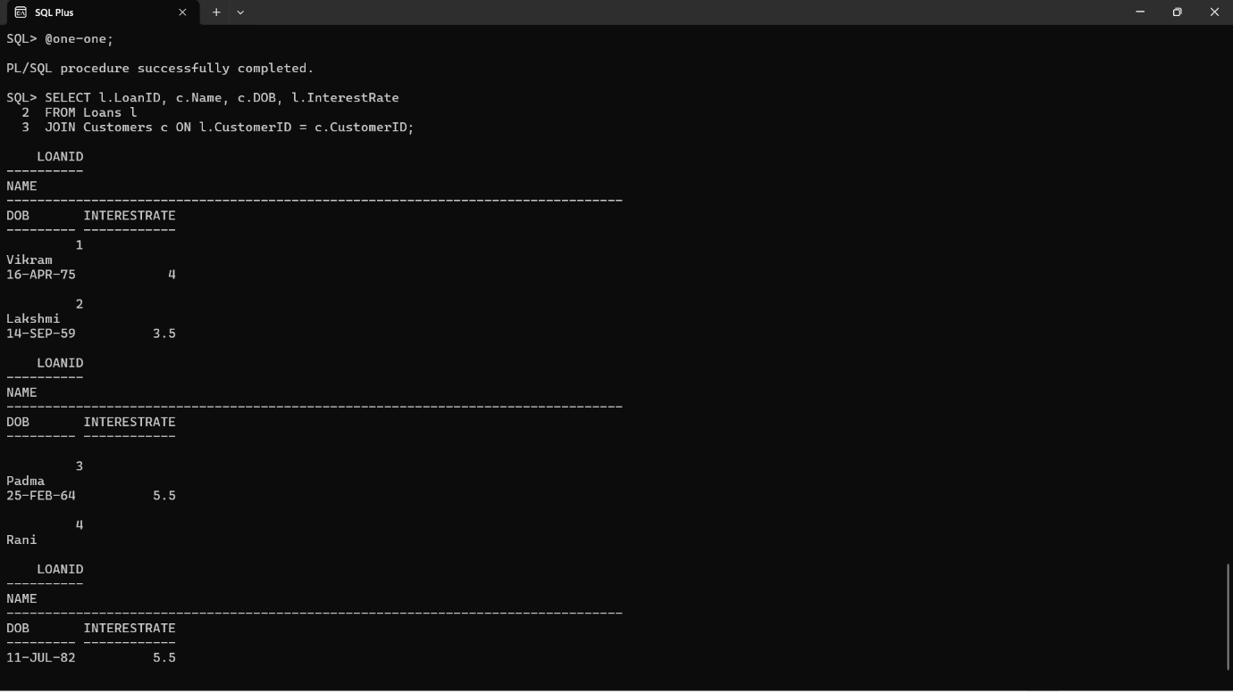

ii) VIP status

BEGIN

FOR cust IN (SELECT CustomerID, Balance FROM Customers) LOOP

IF cust.Balance > 10000 THEN

UPDATE Customers

SET IsVIP = 'TRUE'

WHERE CustomerID = cust.CustomerID;

END IF;

END LOOP;

COMMIT;

END;

/

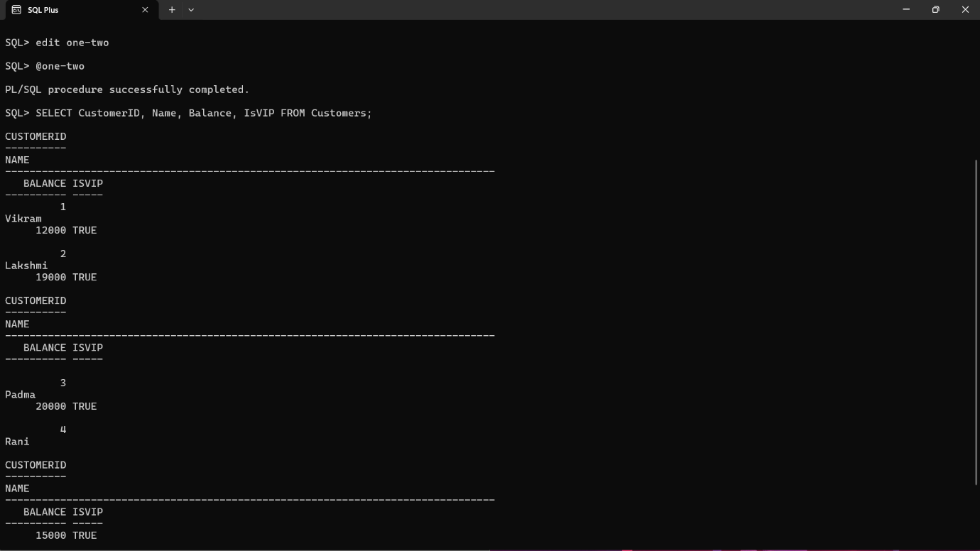

iii) Remainder Message

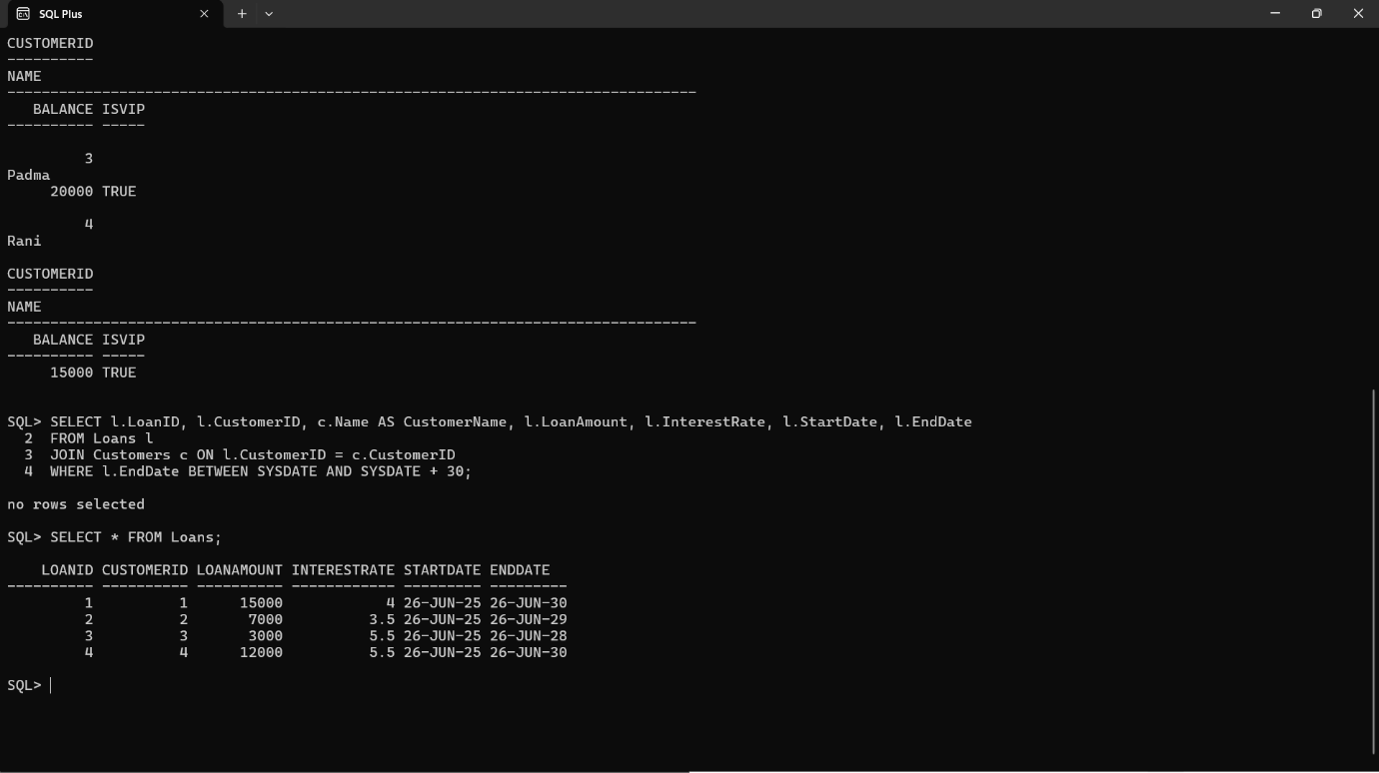

BEGIN

FOR rec IN (

SELECT l.LoanID, l.CustomerID, c.Name, l.EndDate

FROM Loans l

JOIN Customers c ON l.CustomerID = c.CustomerID

WHERE l.EndDate BETWEEN SYSDATE AND SYSDATE + 30

)

LOOP

DBMS_OUTPUT.PUT_LINE('Reminder: Loan ID ' || rec.LoanID ||

' for customer ' || rec.Name ||

' is due on ' || TO_CHAR(rec.EndDate, 'DD-MON-YYYY'));

END LOOP;

END;

/

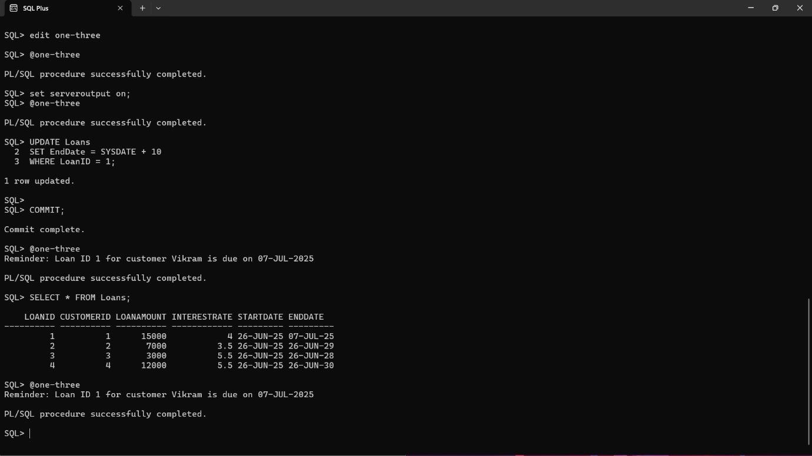

3) Stored Procedures

i) ProcessMonthlyInterest

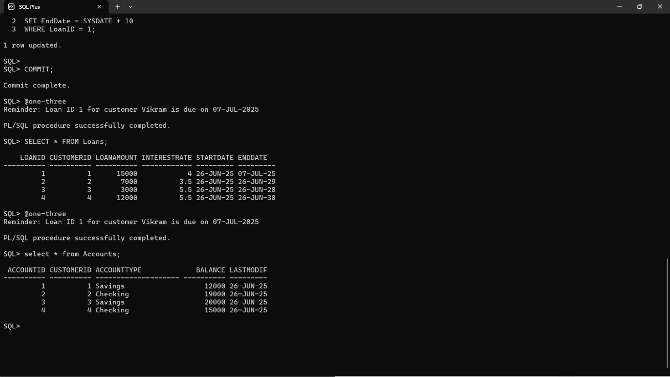

CREATE OR REPLACE PROCEDURE ProcessMonthlyInterest IS

BEGIN

FOR acc IN (

SELECT AccountID, Balance

FROM Accounts

WHERE AccountType = 'Savings'

FOR UPDATE

) LOOP

UPDATE Accounts

SET Balance = acc.Balance + (acc.Balance * 0.01),

LastModified = SYSDATE

WHERE AccountID = acc.AccountID;

END LOOP;

COMMIT;

DBMS_OUTPUT.PUT_LINE('Monthly interest of 1% applied to all savings accounts.');

EXCEPTION

WHEN OTHERS THEN

ROLLBACK;

DBMS_OUTPUT.PUT_LINE('Error applying interest: ' || SQLERRM);

END;

/

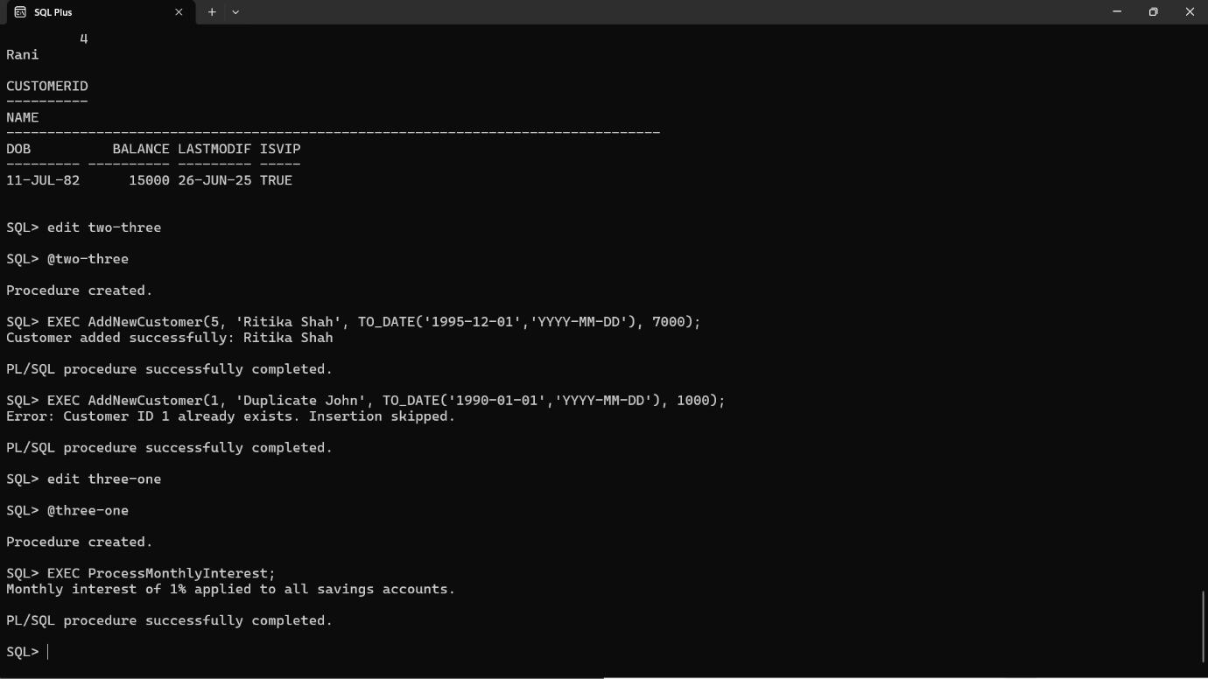

ii) UpdateEmployeeBonus

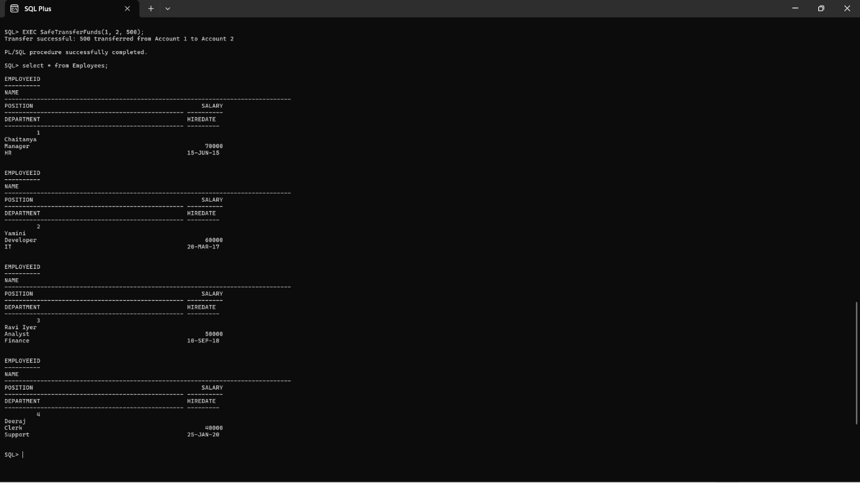

CREATE OR REPLACE PROCEDURE UpdateEmployeeBonus (

p_Department IN VARCHAR2,

p_BonusPercent IN NUMBER

) IS

v_Count NUMBER := 0;

BEGIN

-- Step 1: Update salaries

UPDATE Employees

SET Salary = Salary + (Salary * p_BonusPercent / 100)

WHERE Department = p_Department;

-- Step 2: Check how many rows were updated

v_Count := SQL%ROWCOUNT;

COMMIT;

DBMS_OUTPUT.PUT_LINE('Bonus of ' || p_BonusPercent || '% applied to ' || v_Count || ' employee(s) in department: ' || p_Department);

EXCEPTION

WHEN OTHERS THEN

ROLLBACK;

DBMS_OUTPUT.PUT_LINE('Error updating bonus: ' || SQLERRM);

END;

/

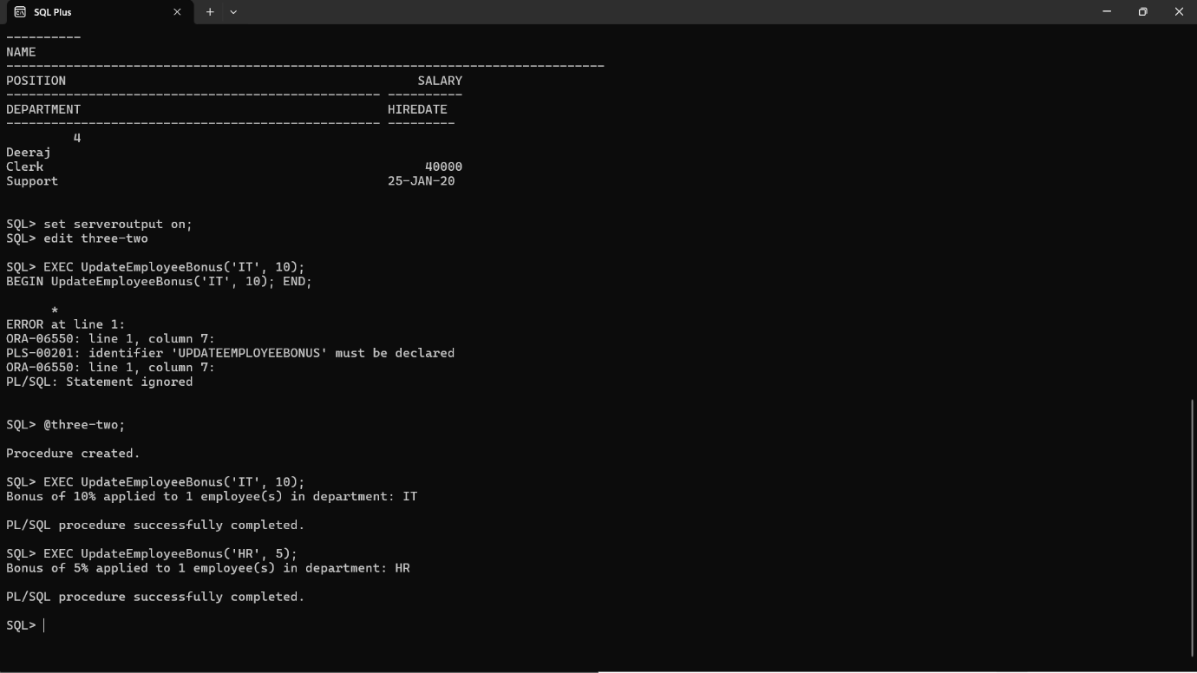

iii) TransferFunds



CREATE OR REPLACE PROCEDURE TransferFunds (

p_FromAccountID IN NUMBER,

p_ToAccountID IN NUMBER,

p_Amount IN NUMBER

) IS

v_SourceBalance NUMBER;

BEGIN

-- Step 1: Get source balance

SELECT Balance INTO v_SourceBalance

FROM Accounts

WHERE AccountID = p_FromAccountID

FOR UPDATE;

-- Step 2: Check for sufficient balance

IF v_SourceBalance < p_Amount THEN

RAISE_APPLICATION_ERROR(-20001, 'Insufficient balance in source account.');

END IF;

-- Step 3: Deduct from source

UPDATE Accounts

SET Balance = Balance - p_Amount,

LastModified = SYSDATE

WHERE AccountID = p_FromAccountID;

-- Step 4: Add to destination

UPDATE Accounts

SET Balance = Balance + p_Amount,

LastModified = SYSDATE

WHERE AccountID = p_ToAccountID;

COMMIT;

DBMS_OUTPUT.PUT_LINE('Successfully transferred ' || p_Amount ||

' from Account ' || p_FromAccountID ||

' to Account ' || p_ToAccountID);

EXCEPTION

WHEN NO_DATA_FOUND THEN

DBMS_OUTPUT.PUT_LINE('Error: One of the accounts does not exist.');

WHEN OTHERS THEN

ROLLBACK;

DBMS_OUTPUT.PUT_LINE('Transfer failed: ' || SQLERRM);

END;

/

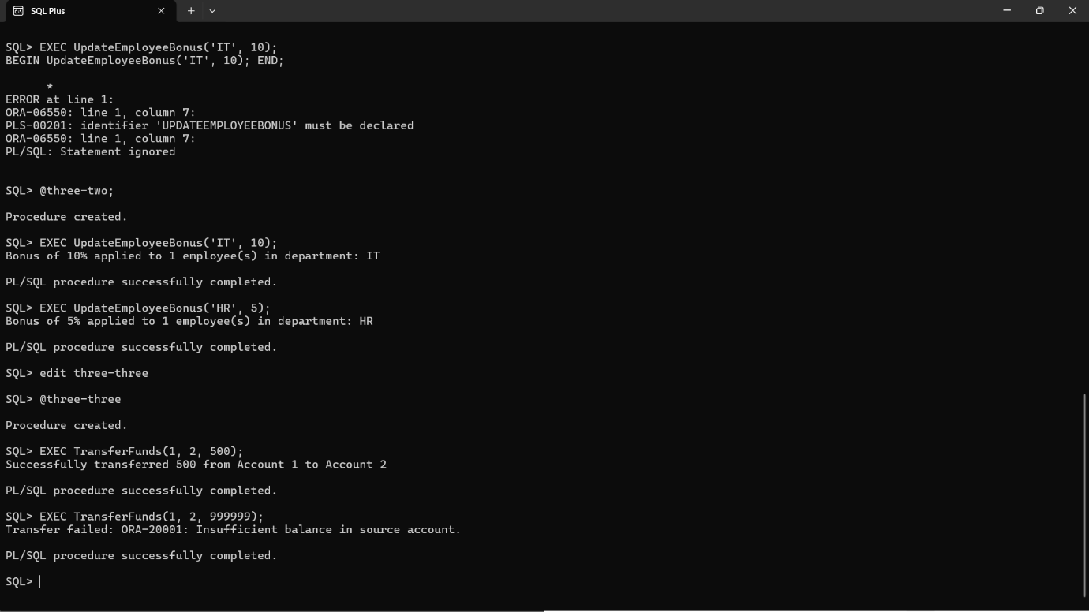

**PRACTICE EXERCISES**

2) ERROR HANDLING

i) SafeTransferFunds



CREATE OR REPLACE PROCEDURE SafeTransferFunds (

p_FromAccountID IN NUMBER,

p_ToAccountID IN NUMBER,

p_Amount IN NUMBER

) IS

v_SourceBalance NUMBER;

BEGIN

-- Step 1: Get source account balance

SELECT Balance INTO v_SourceBalance

FROM Accounts

WHERE AccountID = p_FromAccountID

FOR UPDATE;

-- Step 2: Check for sufficient funds

IF v_SourceBalance < p_Amount THEN

RAISE_APPLICATION_ERROR(-20001, 'Insufficient funds in source account.');

END IF;

-- Step 3: Deduct from source account

UPDATE Accounts

SET Balance = Balance - p_Amount

WHERE AccountID = p_FromAccountID;

-- Step 4: Add to destination account

UPDATE Accounts

SET Balance = Balance + p_Amount

WHERE AccountID = p_ToAccountID;

-- Step 5: Commit if all went well

COMMIT;

DBMS_OUTPUT.PUT_LINE('Transfer successful: ' || p_Amount || ' transferred from Account ' ||

p_FromAccountID || ' to Account ' || p_ToAccountID);

EXCEPTION

WHEN OTHERS THEN

ROLLBACK;

DBMS_OUTPUT.PUT_LINE('Transfer failed: ' || SQLERRM);

END;

/

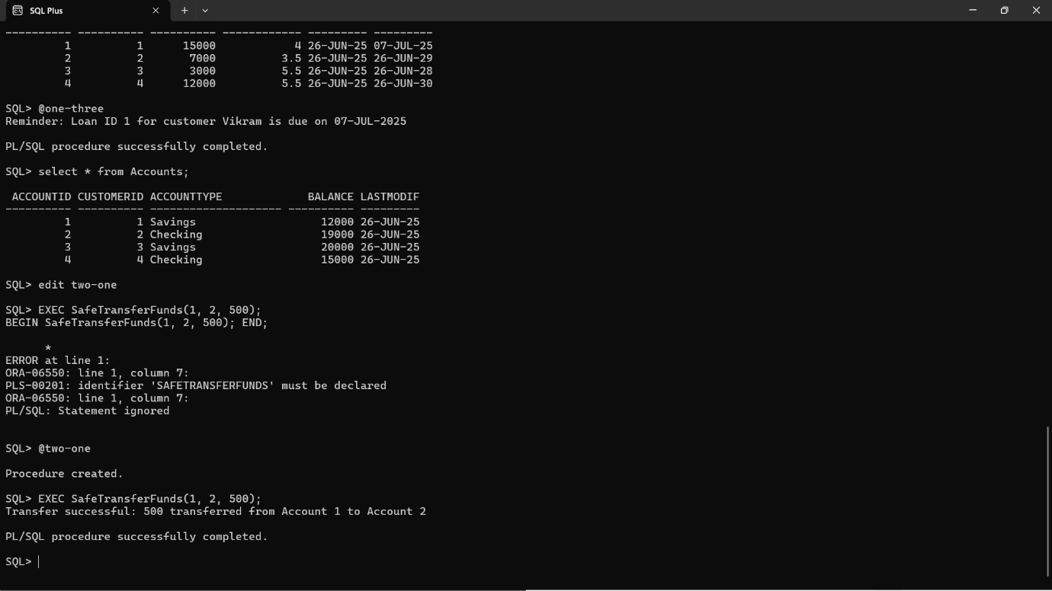

ii) UpdateSalary



CREATE OR REPLACE PROCEDURE UpdateSalary (

p_EmployeeID IN NUMBER,

p_PercentIncrease IN NUMBER

) IS

v_CurrentSalary NUMBER;

BEGIN

-- Step 1: Get current salary

SELECT Salary INTO v_CurrentSalary

FROM Employees

WHERE EmployeeID = p_EmployeeID;

-- Step 2: Update salary by given percent

UPDATE Employees

SET Salary = Salary + (v_CurrentSalary * p_PercentIncrease / 100)

WHERE EmployeeID = p_EmployeeID;

COMMIT;

DBMS_OUTPUT.PUT_LINE('Salary updated successfully for Employee ID ' || p_EmployeeID);

EXCEPTION

WHEN NO_DATA_FOUND THEN

DBMS_OUTPUT.PUT_LINE('Error: Employee ID ' || p_EmployeeID || ' does not exist.');

WHEN OTHERS THEN

DBMS_OUTPUT.PUT_LINE('Unexpected error: ' || SQLERRM);

END;

/

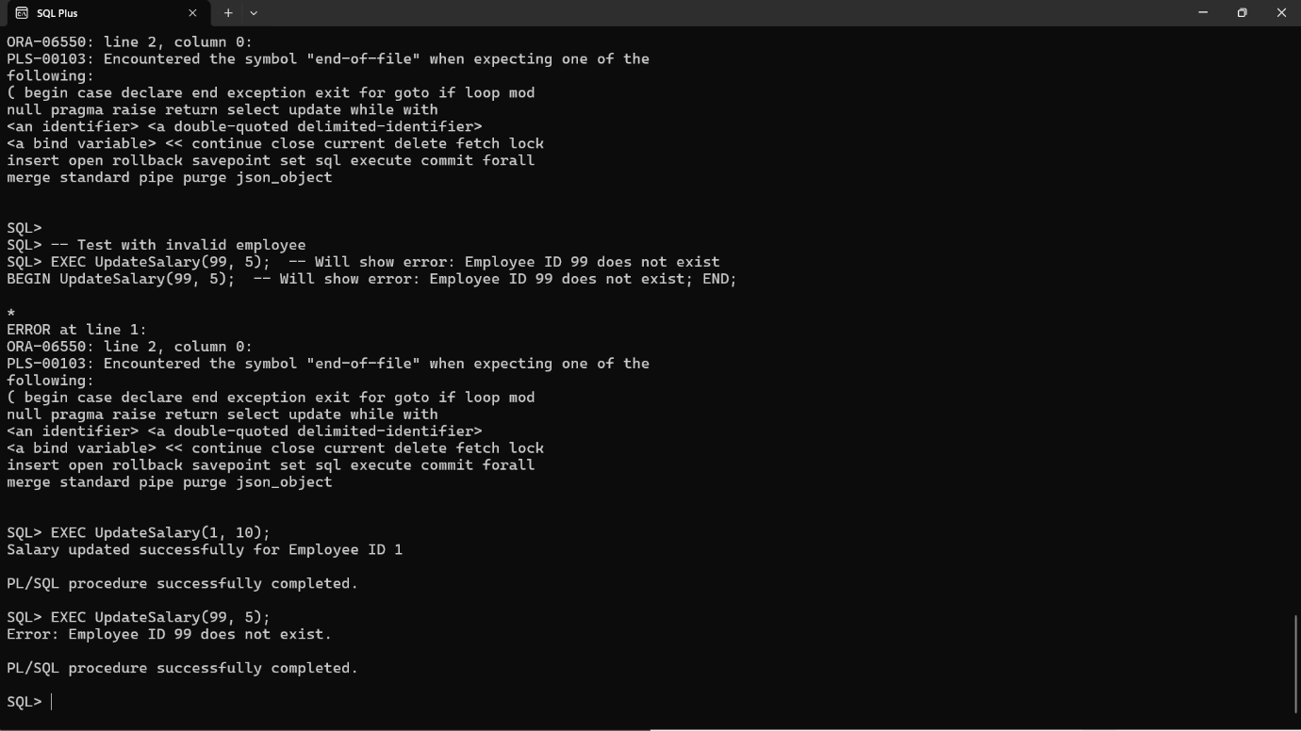

iii) AddNewCustomer

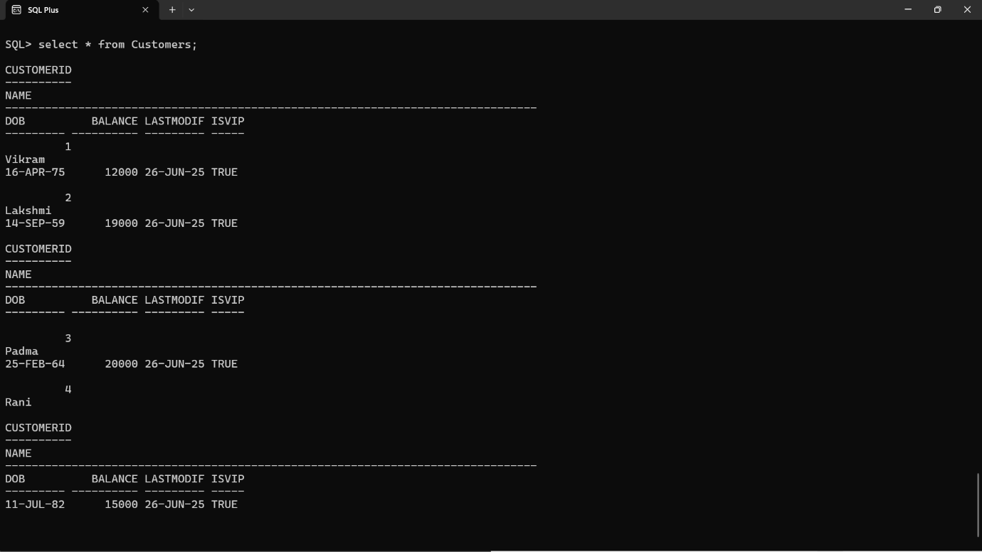

CREATE OR REPLACE PROCEDURE AddNewCustomer (

p_CustomerID IN NUMBER,

p_Name IN VARCHAR2,

p_DOB IN DATE,

p_Balance IN NUMBER

) IS

BEGIN

INSERT INTO Customers (CustomerID, Name, DOB, Balance, LastModified)

VALUES (p_CustomerID, p_Name, p_DOB, p_Balance, SYSDATE);

COMMIT;

DBMS_OUTPUT.PUT_LINE('Customer added successfully: ' || p_Name);

EXCEPTION

WHEN DUP_VAL_ON_INDEX THEN

DBMS_OUTPUT.PUT_LINE('Error: Customer ID ' || p_CustomerID || ' already exists. Insertion skipped.');

WHEN OTHERS THEN

DBMS_OUTPUT.PUT_LINE('Unexpected error: ' || SQLERRM);

END;

/

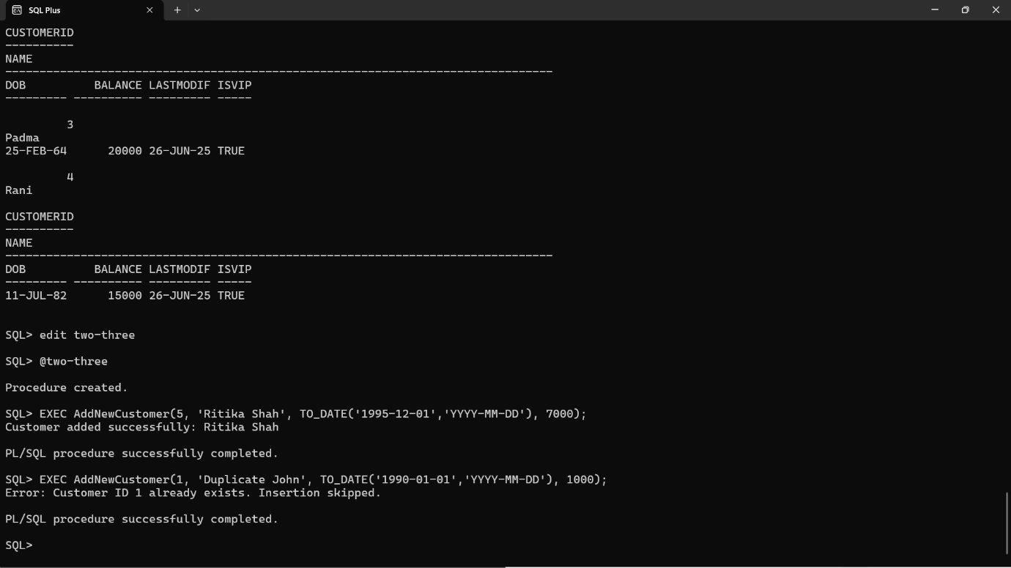

4) FUNCTIONS

i) Calculate Age

  
CREATE OR REPLACE FUNCTION CalculateAge (

p_DOB IN DATE

) RETURN NUMBER IS

v_Age NUMBER;

BEGIN

v_Age := TRUNC(MONTHS_BETWEEN(SYSDATE, p_DOB) / 12);

RETURN v_Age;

END;

/

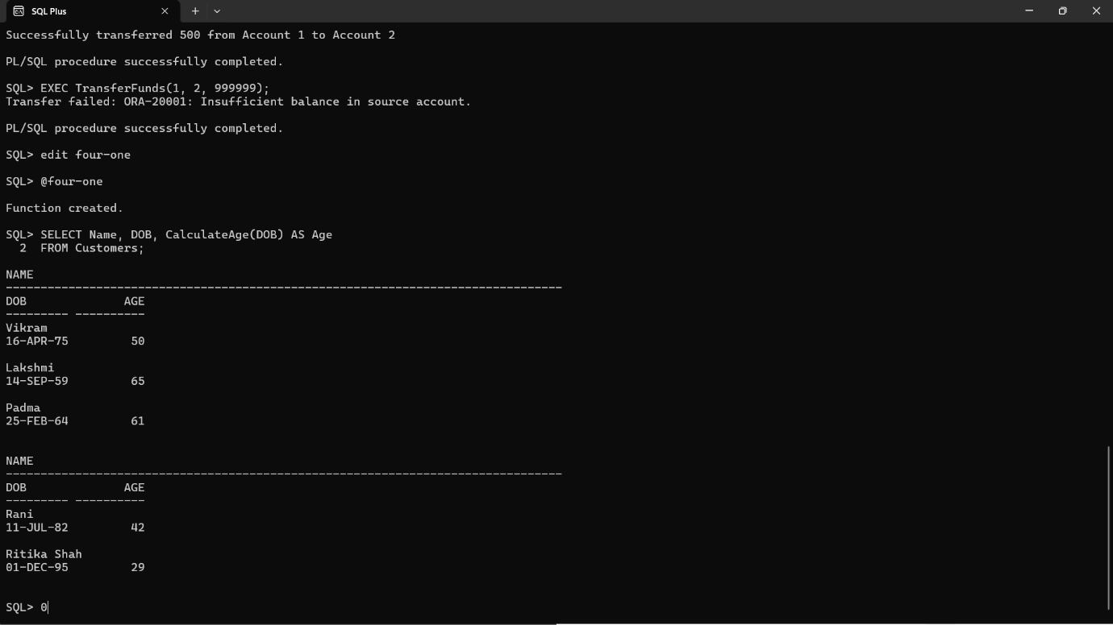

ii) Calculate Monthly Installment

CREATE OR REPLACE FUNCTION CalculateMonthlyInstallment (

p_LoanAmount IN NUMBER,

p_InterestRate IN NUMBER,

p_DurationYears IN NUMBER

) RETURN NUMBER IS

v_MonthlyRate NUMBER;

v_TotalMonths NUMBER;

v_EMI NUMBER;

BEGIN

v_MonthlyRate := p_InterestRate / 12 / 100;

v_TotalMonths := p_DurationYears * 12;

v_EMI := (p_LoanAmount * v_MonthlyRate * POWER(1 + v_MonthlyRate, v_TotalMonths)) /

(POWER(1 + v_MonthlyRate, v_TotalMonths) - 1);

RETURN ROUND(v_EMI, 2);

EXCEPTION

WHEN ZERO_DIVIDE THEN

RETURN NULL;

WHEN OTHERS THEN

RETURN NULL;

END;

/

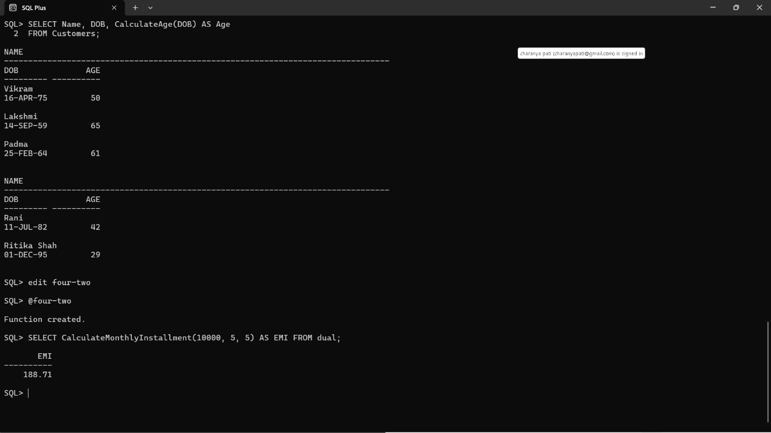

iii) HasSufficientBalance

CREATE OR REPLACE FUNCTION HasSufficientBalance (

p_AccountID IN NUMBER,

p_Amount IN NUMBER

) RETURN BOOLEAN IS

v_Balance NUMBER;

BEGIN

SELECT Balance INTO v_Balance

FROM Accounts

WHERE AccountID = p_AccountID;

RETURN v_Balance >= p_Amount;

EXCEPTION

WHEN NO_DATA_FOUND THEN

DBMS_OUTPUT.PUT_LINE('Error: Account ID ' || p_AccountID || ' not found.');

RETURN FALSE;

WHEN OTHERS THEN

DBMS_OUTPUT.PUT_LINE('Unexpected error: ' || SQLERRM);

RETURN FALSE;

END;

/

DECLARE

v_Result BOOLEAN;

BEGIN

v_Result := HasSufficientBalance(1, 5000); -- Change account ID and amount as needed

IF v_Result THEN

DBMS_OUTPUT.PUT_LINE('Sufficient balance.');

ELSE

DBMS_OUTPUT.PUT_LINE('Insufficient balance.');

END IF;

END;

/

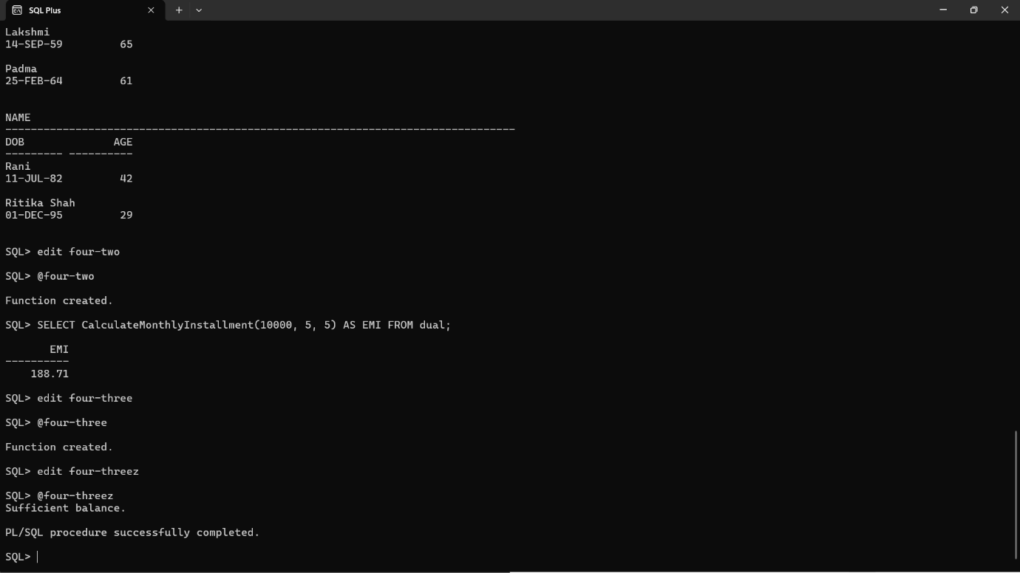

5) TRIGGERS

i) UpdateCustomerLastModified

CREATE OR REPLACE TRIGGER UpdateCustomerLastModified

BEFORE UPDATE ON Customers

FOR EACH ROW

BEGIN

:NEW.LastModified := SYSDATE;

END;

/

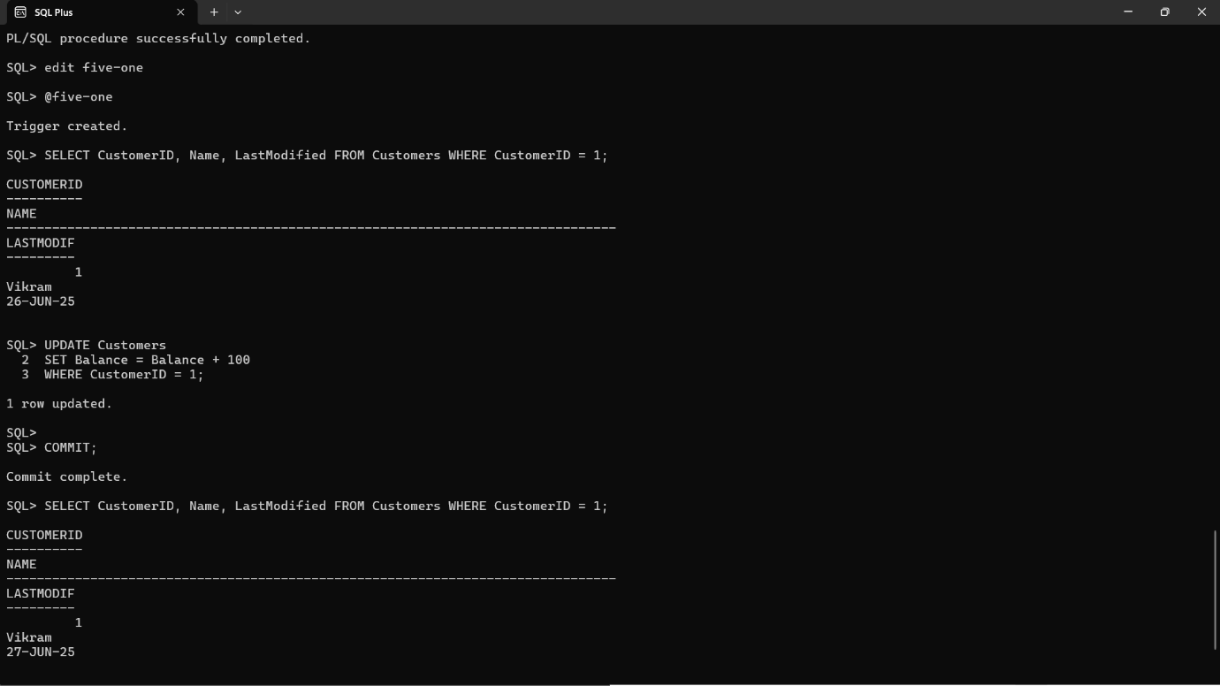

ii) LogTransaction

CREATE OR REPLACE TRIGGER LogTransaction

AFTER INSERT ON Transactions

FOR EACH ROW

BEGIN

INSERT INTO AuditLog (

TransactionID,

AccountID,

Action,

LogDate

) VALUES (

:NEW.TransactionID,

:NEW.AccountID,

'INSERTED TRANSACTION',

SYSDATE

);

END;

/

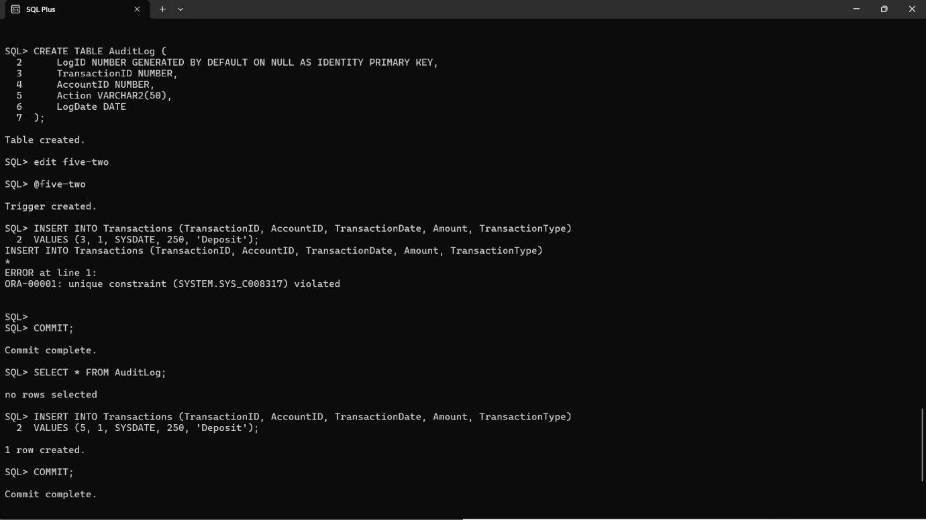

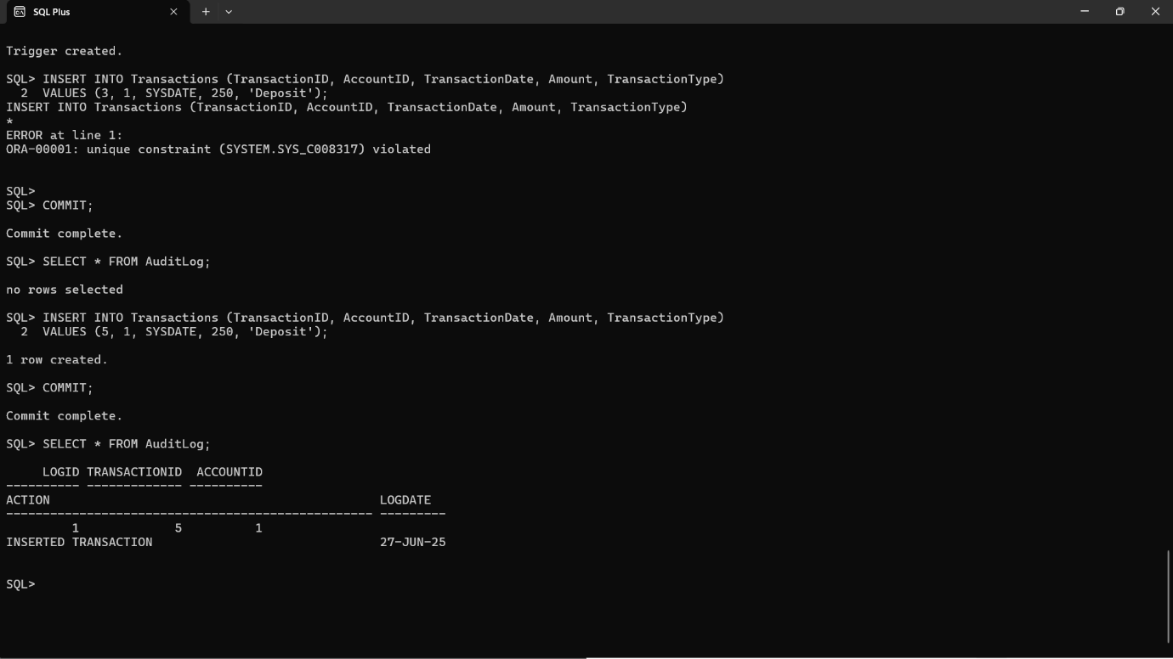

iii) CheckTransactionRules

CREATE OR REPLACE TRIGGER CheckTransactionRules

BEFORE INSERT ON Transactions

FOR EACH ROW

DECLARE

v_Balance NUMBER;

BEGIN

-- Get the current balance of the account

SELECT Balance INTO v_Balance

FROM Accounts

WHERE AccountID = :NEW.AccountID;

-- Rule 1: Deposit must be positive

IF :NEW.TransactionType = 'Deposit' THEN

IF :NEW.Amount <= 0 THEN

RAISE_APPLICATION_ERROR(-20001, 'Deposit amount must be greater than 0.');

END IF;

-- Rule 2: Withdrawal must not exceed balance

ELSIF :NEW.TransactionType = 'Withdrawal' THEN

IF :NEW.Amount > v_Balance THEN

RAISE_APPLICATION_ERROR(-20002, 'Insufficient balance for withdrawal.');

END IF;

END IF;

END;

/

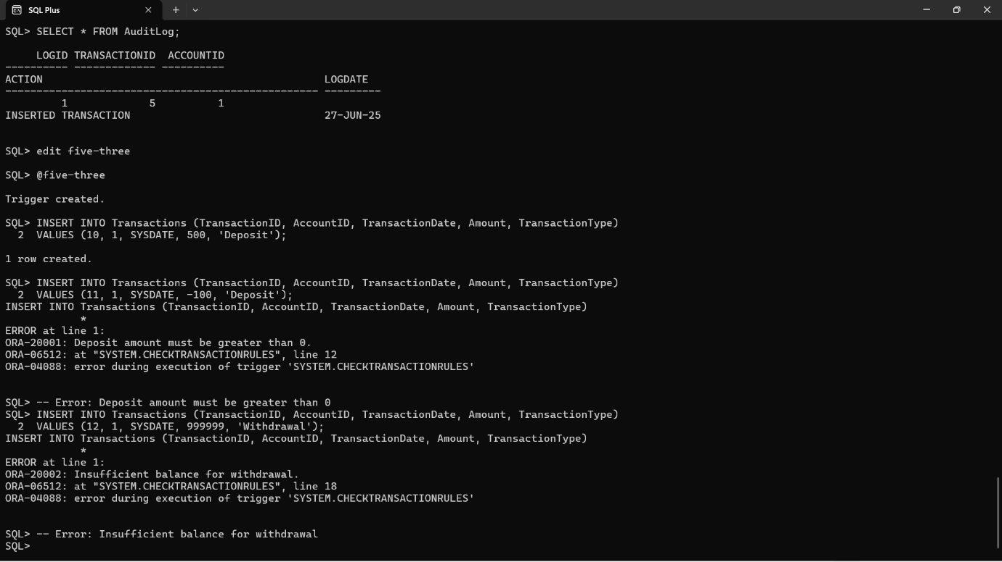

6) CURSORS

i) GeneratemonthlyStatements

SET SERVEROUTPUT ON;

DECLARE

CURSOR txn_cursor IS

SELECT

t.TransactionID,

t.AccountID,

c.CustomerID,

c.Name AS CustomerName,

t.TransactionDate,

t.Amount,

t.TransactionType

FROM Transactions t

JOIN Accounts a ON t.AccountID = a.AccountID

JOIN Customers c ON a.CustomerID = c.CustomerID

WHERE EXTRACT(MONTH FROM t.TransactionDate) = EXTRACT(MONTH FROM SYSDATE)

AND EXTRACT(YEAR FROM t.TransactionDate) = EXTRACT(YEAR FROM SYSDATE)

ORDER BY c.CustomerID, t.TransactionDate;

v_LastCustomerID NUMBER := NULL;

BEGIN

DBMS_OUTPUT.PUT_LINE('--- Monthly Transaction Statements ---');

FOR txn IN txn_cursor LOOP

-- Header for each new customer

IF v_LastCustomerID IS NULL OR v_LastCustomerID != txn.CustomerID THEN

DBMS_OUTPUT.PUT_LINE('---------------------------------------');

DBMS_OUTPUT.PUT_LINE('Customer: ' || txn.CustomerName || ' (ID: ' || txn.CustomerID || ')');

DBMS_OUTPUT.PUT_LINE('Transactions:');

v_LastCustomerID := txn.CustomerID;

END IF;

-- Transaction line

DBMS_OUTPUT.PUT_LINE(' [' || TO_CHAR(txn.TransactionDate, 'DD-MON') || '] ' ||

txn.TransactionType || ' of $' || txn.Amount);

END LOOP;

DBMS_OUTPUT.PUT_LINE('---------------------------------------');

END;

/

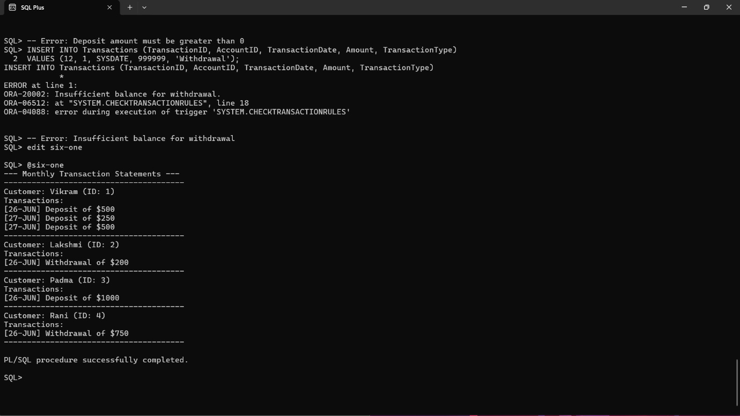

ii) ApplyAnnualFee

SET SERVEROUTPUT ON;

DECLARE

-- Define the annual maintenance fee

v_AnnualFee NUMBER := 100;

-- Cursor to loop through all accounts

CURSOR acc_cursor IS

SELECT AccountID, Balance

FROM Accounts

FOR UPDATE;

BEGIN

DBMS_OUTPUT.PUT_LINE('--- Applying Annual Maintenance Fee ---');

-- Loop through each account

FOR acc IN acc_cursor LOOP

-- Deduct fee and update LastModified

UPDATE Accounts

SET Balance = Balance - v_AnnualFee,

LastModified = SYSDATE

WHERE AccountID = acc.AccountID;

-- Output confirmation

DBMS_OUTPUT.PUT_LINE('Annual fee of $' || v_AnnualFee ||

' deducted from Account ID ' || acc.AccountID);

END LOOP;

COMMIT;

DBMS_OUTPUT.PUT_LINE('--- Annual fee applied to all accounts successfully ---');

END;

/

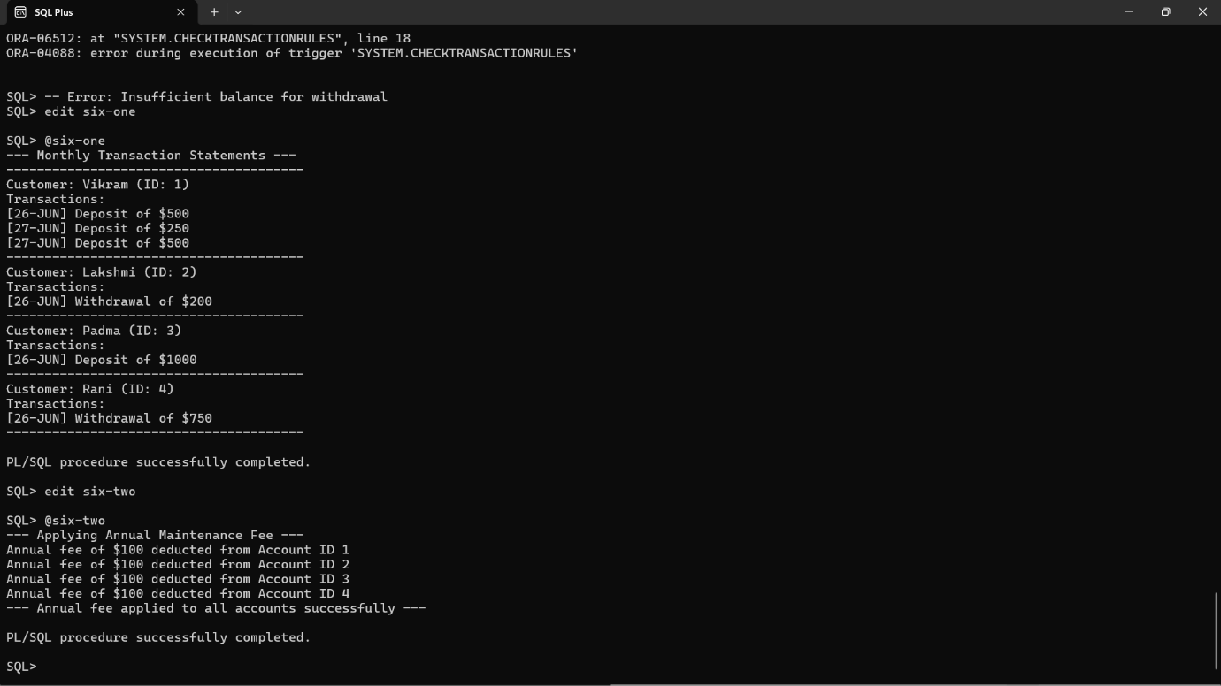

iii) UpdateLoanInterestRates

SET SERVEROUTPUT ON;

DECLARE

CURSOR loan_cursor IS

SELECT LoanID, LoanAmount, InterestRate

FROM Loans

FOR UPDATE;

v_NewRate NUMBER;

BEGIN

DBMS_OUTPUT.PUT_LINE('--- Updating Loan Interest Rates Based on Policy ---');

FOR loan_rec IN loan_cursor LOOP

-- Apply new policy rules

IF loan_rec.LoanAmount > 10000 THEN

v_NewRate := loan_rec.InterestRate - 0.5;

ELSIF loan_rec.LoanAmount BETWEEN 5000 AND 10000 THEN

v_NewRate := loan_rec.InterestRate - 0.25;

ELSE

v_NewRate := loan_rec.InterestRate;

END IF;

-- Update loan if rate changed

IF v_NewRate != loan_rec.InterestRate THEN

UPDATE Loans

SET InterestRate = v_NewRate

WHERE LoanID = loan_rec.LoanID;

DBMS_OUTPUT.PUT_LINE('Loan ID ' || loan_rec.LoanID ||

' updated from ' || loan_rec.InterestRate || '% to ' || v_NewRate || '%');

END IF;

END LOOP;

COMMIT;

DBMS_OUTPUT.PUT_LINE('--- Loan interest rate updates completed ---');

END;

/

